# Exercises: Install Truffle and Ganache

The goal of this exercise is to install **Truffle** and **Ganache**. **Truffle** is the most popular development framework for **Ethereum** with a mission to make your life a whole lot easier. **Ganache** is part of the **Truffle Suite**. It is one click blockchain, which allows you to quickly fire up a personal Ethereum blockchain, which you can use to run tests, execute commands, and inspect state while controlling how the chain operates. Ganache simplifies **Dapp** development by placing your contracts and transactions front and center. Using Ganache, you can quickly see how your application affects the blockchain, and introspect details like your accounts, balances, contract creations and gas costs. You can also fine tune Ganache's advanced mining controls to better suit your needs.

## Install NodeJS

1. **Truffle** requires **NodeJS** to be installed, so let’s first get NodeJS. If you already have **NodeJS** go to next chapter – Install Truffle. In other case, continue reading. In order to install NodeJS, we just have to use the **apt package manager**. We should refresh our local package index first, and then install from the repositories. In Linux console type:

|  |
| --- |
| sudo apt-get update |

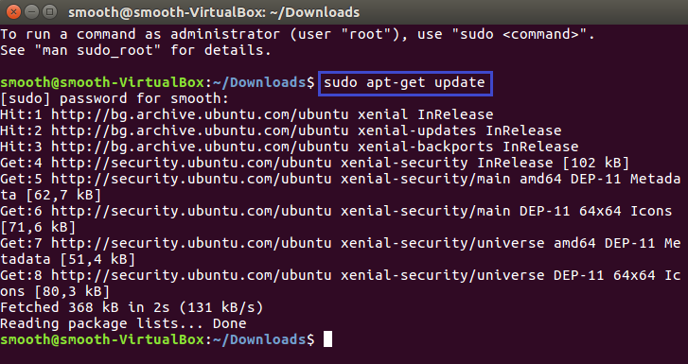

1. Now we are ready to install **NodeJS**. Type in console:

|  |
| --- |
| sudo apt-get install nodejs |

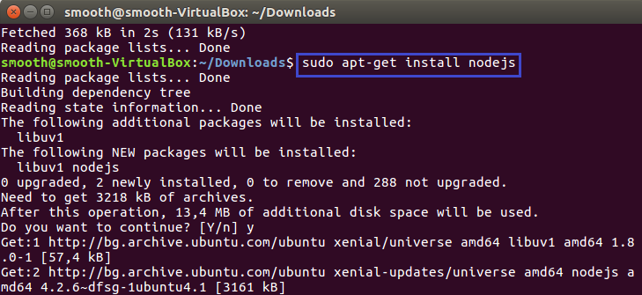

1. If the package in the repositories suits your needs, this is all you need to do to get set up with **Node.js**. In most cases, you will also want to install **npm**, which is the Node.js **package manager**. This will allow you to easily **install modules and packages** to use with Node.js.   
   To start installation type:

|  |
| --- |
| sudo apt-get install npm |

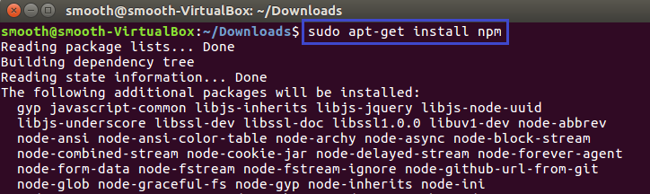

1. Now it is good idea to check which version of Node.js you have installed after these initial steps, type:

|  |
| --- |
| nodejs -v |

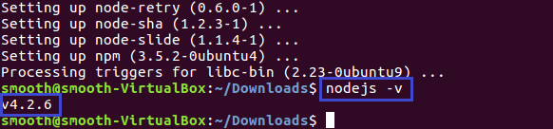

1. Update nodejs.

|  |
| --- |
| curl -sL https://deb.nodesource.com/setup_8.x | sudo -E bash -  sudo apt-get install -y nodejs |

## Install Truffle

1. **Open** the console and type:

|  |
| --- |
| npm install –g truffle |

or

|  |
| --- |
| sudo npm install –g truffle |

if you have no write access to **/usr/local/lib/node_modules**.

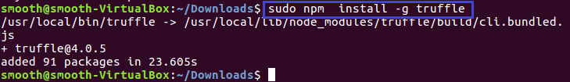

## Install Ganache

1. Open <https://github.com/trufflesuite/ganache/releases/tag/v1.0.2> and select the appropriate version.

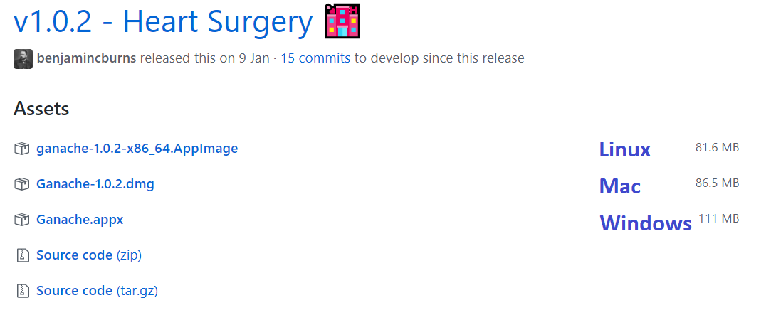

1. Download the file.
2. The fileyou just saved is **AppImage. AppImages** can be downloaded and run without installation or the need for root rights. But first, you must make it executable file.
3. On this purpose open console and type:

|  |
| --- |
| chmod a+x ganache-1.0.2-x86_64.AppImage |

1. Now you can **run** the file with **double click**.
2. Now you can allow or not Ganache to analyze your data or not. Make a choice and click **continue**.

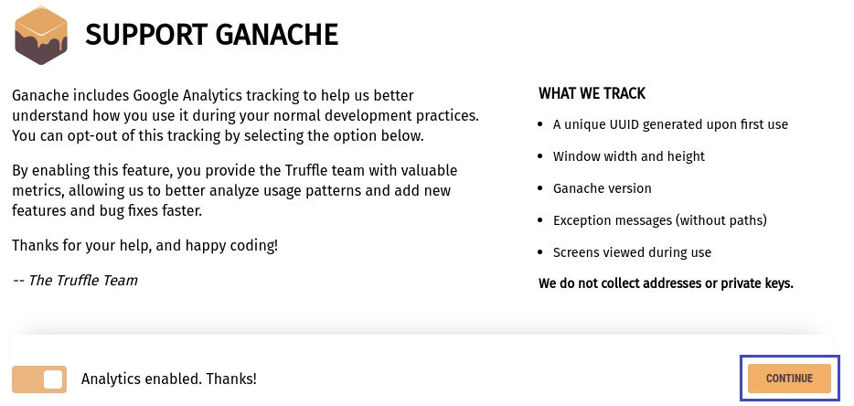

1. Congratulations! You successfully install Ganache!

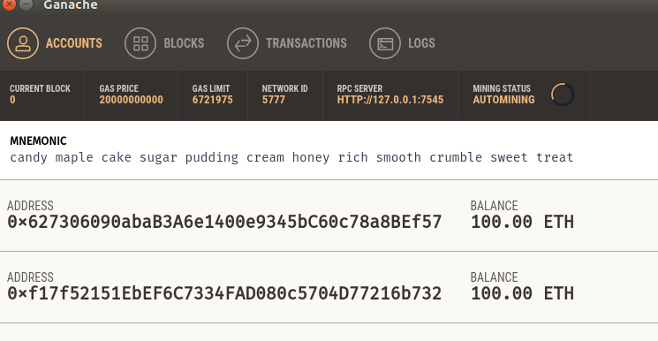

In **Windows** environment, use PowerShell to install the Ganache.appx package:

